United States
Securities and Exchange Commission
Washington, D.C. 20549
FORM 6-K
Report of Foreign Private Issuer
Pursuant to Rule 13a-16 or 15d-16
under the Securities Exchange Act of 1934

July 2, 2026

Commission File Number 001-37791
COCA-COLA EUROPACIFIC PARTNERS PLC
Pemberton House, Bakers Road
Uxbridge, UB8 1EZ, United Kingdom

(Address of principal executive office)
(Indicate by check mark whether the registrant files or will file annual reports under cover of Form 20-F or Form 40-F.)
(Check One) Form 20-F ☒ Form 40-F D ☐

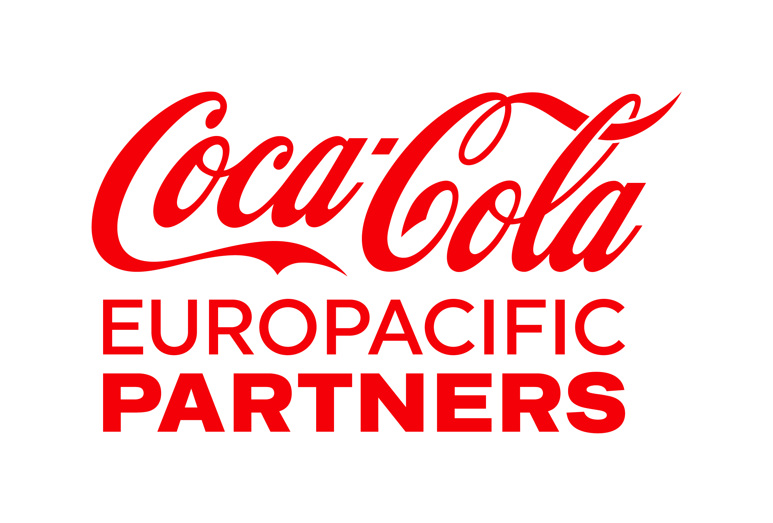

THIS ANNOUNCEMENT IS FOR INFORMATION PURPOSES ONLY AND DOES NOT CONSTITUTE AN OFFER OR INVITATION TO PURCHASE ANY SECURITIES IN ANY JURISDICTION OR A SOLICITATION OF ANY VOTE OR APPROVAL.

NOT FOR RELEASE, PUBLICATION OR DISTRIBUTION (DIRECTLY OR INDIRECTLY) IN WHOLE OR IN PART IN, INTO OR FROM ANY JURISDICTION WHERE TO DO SO WOULD CONSTITUTE A VIOLATION OF THE RELEVANT LAWS OR REGULATIONS OF THAT JURISDICTION.

Coca-Cola Europacific Partners plc announces update to share buyback programme

2 July 2026

On 17 February 2026, Coca-Cola Europacific Partners plc (the "Company") announced its intention to return up to €1bn to shareholders through a coordinated share buyback programme on (i) Nasdaq and other applicable US trading venues ("the US Trading Venues") and (ii) the London Stock Exchange, CBOE Europe Limited (through the BXE and CXE order books) and Aquis (the "London Trading Venues") (the "Programme"). The purpose of the Programme is to reduce the issued share capital of the Company. All shares repurchased as part of the Programme will be cancelled. The first tranche of the Programme, which was for an aggregate amount of up to €500mn, commenced on 18 February 2026 and completed on 24 April 2026.

The second tranche of the Programme is expected to commence on 6 July 2026 and the Company has entered into an arrangement in relation to this second tranche of the Programme with Goldman Sachs & Co. LLC and Goldman Sachs International (together with their affiliates "GS"), consisting of two contracts to enable the purchase of ordinary shares on both the US Trading Venues and the London Trading Venues. GS will act as riskless principal, share purchases will be made in accordance with the arrangement and effected within certain contractually agreed parameters, and shall be made independently of and uninfluenced by the Company.

The second tranche of the Programme is expected to cover the period from 6 July 2026 up to and including 18 December 2026, although it may complete earlier than that date. The aggregate amount for purchases in respect of this second tranche of the Programme is up to €500mn, of which up to €130mn will be in respect of the London Trading Venues. The second tranche is the final tranche of the Programme, and if executed in full the Company will have returned up to c. €1bn to shareholders under the Programme.

Additional details

The Programme will be effected in accordance with (i) (in relation to purchases made on the London Trading Venues) the scope of the authority to repurchase ordinary shares "on market" conferred on the Company at the 2026 Annual General Meeting; (ii) (in relation to purchases made on the US Trading Venues) the scope of the authority to repurchase ordinary shares "off market" conferred on the Company at the 2026 Annual General Meeting; (iii) (in relation to purchases made on the London Trading Venues) (EU) No 596/2014 (the Market Abuse Regulation) and the Commission Delegated Regulation (EU) 2016/1052 as applicable (both as in force in the UK, and as they form part of retained UK law as defined in the European Union (Withdrawal) Act 2018); (iv) Chapter 9 of the UK Listing Rules; and (v) applicable U.S. federal securities laws, including applicable US securities laws and anti-manipulation provisions thereof. In relation to purchases on the London Trading Venues, GS will acquire CREST depositary interests on the London Trading Venues, which will be cancelled together with the underlying shares they represent.

The maximum number of ordinary shares which may be purchased or committed to be purchased by the Company under the contracts entered into in respect of this second tranche of the Programme is 42,289,442 (which is the maximum remaining number pursuant to the relevant authorities granted by shareholders at the Company’s 2026 Annual General Meeting after taking into account shares acquired pursuant to the first tranche of the Programme).

2
Cautionary note on forward-looking statements

This document contains statements, estimates or projections that constitute “forward-looking statements” concerning the financial condition, performance, results, guidance and outlook, dividends, consequences of mergers, acquisitions, joint ventures, divestitures, strategy and objectives of Coca-Cola Europacific Partners plc and its subsidiaries (together CCEP or the Group). Generally, the words “ambition”, “target”, “aim”, “believe”, “expect”, “intend”, “estimate”, “anticipate”, “project”, “plan”, “seek”, “may”, “could”, “would”, “should”, “might”, “will”, “forecast”, “outlook”, “guidance”, “possible”, “potential”, “predict”, “objective” and similar expressions identify forward-looking statements, which generally are not historical in nature.

Forward-looking statements are subject to certain risks that could cause actual results to differ materially. Forward-looking statements are based upon various assumptions as well as CCEP’s historical experience and present expectations or projections. As a result, undue reliance should not be placed on forward-looking statements, which speak only as of the date on which they are made. Factors that, in CCEP’s view, could cause such actual results to differ materially from forward-looking statements include, but are not limited to, those set forth in the “Risk Factors” section of CCEP’s 2025 Annual Report on Form 20-F filed with the SEC on 13 March 2026 and subsequent filings.

CONTACTS
Company Secretariat  Svetlana Walker  svetlana.walker@ccep.com |  |  | Investor Relations  Sarah Willett  sarah.willett@ccep.com |  |  | Media Relations  Shanna Wendt  mediaenquiries@ccep.com

ABOUT CCEP

Coca-Cola Europacific Partners is one of the world's leading consumer goods companies. We make, move and sell some of the world's most loved brands - serving nearly 600 million consumers and helping over 4 million customers across 31 countries grow.

We combine the strength and scale of a large, multi-national business with an expert, local knowledge of the customers we serve and communities we support.

The Company is currently listed on Euronext Amsterdam, NASDAQ (and a constituent of the Nasdaq 100), London Stock Exchange and on the Spanish Stock Exchanges, trading under the symbol CCEP.

For more information about CCEP, please visit www.cocacolaep.com and follow CCEP on LinkedIn

3
SIGNATURE
Pursuant to the requirements of the Securities Exchange Act of 1934, the Registrant has duly caused this report to be signed on its behalf by the undersigned hereunto duly authorized.

 |  |  | COCA-COLA EUROPACIFIC PARTNERS PLC
 |  |  |  |  |  | (Registrant)
Date: July 2, 2026 |  |  | By: |  |  | /s/ Svetlana Walker
 |  |  | Name: |  |  | Svetlana Walker
 |  |  | Title: |  |  | General Counsel & Company Secretary

4

